Date: 9-3-2013

To: Tara Smith

From: Lianwu Liu

Prabhjot Sandhu

Delta Modeling Section

Bay-Delta Office

Department of Water Resources

Subject: DSM2 Version 8.1 Calibration with NAVD88 datum

## Introduction

A new calibration has been performed for Version 8.1 of DSM2. Version 8.1 incorporates latest improvements to DSM2 code. The main differences in DSM2 version 8.1 include: DSM2-Qual model formulation change to improve model convergence (presented at CWEMF 2011 conference and discussed in (Liu & Ateljevich, Improvements to DSM2-Qual: Part 1,2011)); modifications to the DSM2-Hydro program source code that improve channel geometry calculation (presented at CWEMF 2012 conference and documented in (Liu & Ateljevich, Improved Geometry Interpolation in DSM2-Hydro, 2012)); datum conversion to NAVD88; and Martinez EC boundary correction. Since these changes affect results both in DSM2 Hydro and Qual, a new calibration is needed. This calibration is done by adjusting Manning’s coefficient values in Hydro and dispersion coefficients in Qual. Some channel cross sections were corrected. Further improvements involving other changes, e.g. new bathymetry and grid change, may come in future releases.

## Hydrodynamics Calibration

This calibration is based on the 2009 BDCP Calibration grid (often referred to as mini-calibration, CH2M Hill, October 2009), and converted to NAVD88. CDEC has been reporting stage data in NAVD88 since 2006. Before then, although stage stations were reported using a common datum (NGVD 1929), in fact individual stage stations had different, unknown local datums. It should be more accurate to use NAVD88 and convenient for comparing stage with observed data. Minor changes were made to some channels and cross sections, e.g. channel 141, 144 were corrected. Some cross sections having negative conveyance gradient (dConveyance) were modified. Some corrections were made to Martinez stage and Clifton Court Gate operation data.

Sensitivity tests of model and tidefile time steps were done; the time steps chosen for this calibration were 15, 30, 15 minutes for Hydro, the tidefile, and Qual, respectively (the tidefile is output by Hydro and contains hydrodynamic data for use in Qual).

The Hydro calibration period was from 10/1/2001 to 10/1/2002 and 10/1/2007 to 10/1/2008, and validation periods from 10/1/2006 to 10/1/2007 and 10/1/2009 to 10/1/2009. The calibration stations are listed in Table 1 and shown in Figure 1.

**Table 1 Hydrodynamics Calibration Locations**



*Datum inconsistency at some stations not resolved.

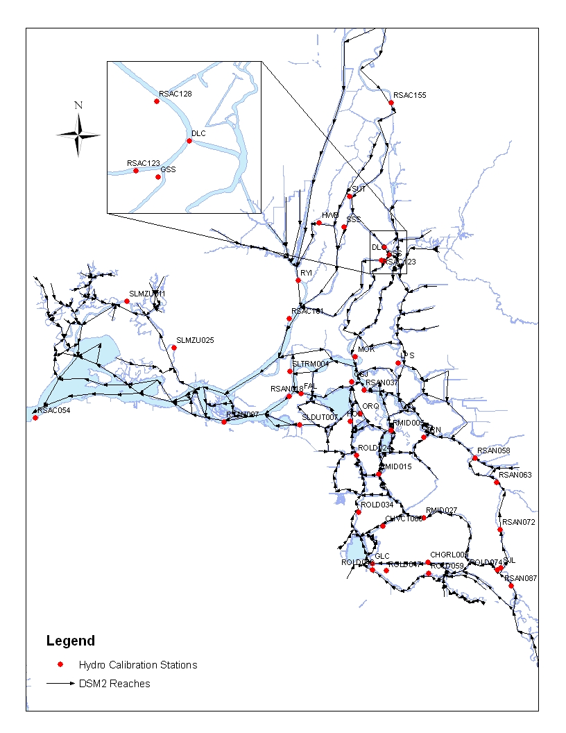**Figure 1 Hydro Calibration Stations**

The model was primarily calibrated to match observed flows. Manning’s coefficient values were adjusted for Hydro calibration. Stage was also compared to observed data in the same format as flow comparison. The calibration metrics are composed of five figures for each station:

* **Timeseries comparison of instantaneous flow.** This plot compares modeled and observed instantaneous flow. We show only 5 days in order to be able to see the tidal process and comparison clearly.
* **Timeseries comparison of tidally-filtered daily-averaged flow.** This plot compares modeled and observed tidally averaged flow, or net flow. Net flow is critical for flow distribution and for salt transport.
* **Linear regression analysis of tidally-filtered daily-averaged flow.** This scatter plot with a linear regression trend line shows statistically the comparison of the simulated vs. observed daily averaged flow. R2 value gives information about the goodness of fit of the model. The trend line shows over- or under-predicting of the model.
* **Linear regression analysis of instantaneous flow.** This analysis followed a similar procedure described in the “Flooded Islands Pre-Feasibility Study” report (RMA 2005). The phase difference between the modeled and measured time series was determined using a cross-correlation procedure, and the modeled time series was shifted with the calculated phase lag before doing the regression analysis. The phase difference is noted in the figure. A positive value indicates that the simulated tidal process lags behind the observed record, while a negative value indicates a faster response by the model. The slope of the regression line approximates the amplitude ratio for modeled vs. observed tidal process. R2 value gives information about the goodness of fit of the model. This plot was generated using data from 5/15/2008 to 7/15/2008. This short period of low flow was selected to better represent the tidal process. It is difficult to use the whole calibration period since high flow periods may have bigger net flow errors, which may be difficult to portray in a figure.
* **Daily Maximum, Average, Minimum comparison.** This plot compares modeled and observed daily maximum, average, minimum flow over the entire calibration period. It is easy to see how the model is doing overall in the entire calibration period.

Since overall the calibrated flow in 2009 BDCP Calibration matched observed data reasonably well, the 2009 calibration was used as a reference. Manning’s n values were adjusted by groups. 26 adjustments/runs were made to reach the satisfactory result.

Due to the bug fixes of channel area interpolation, Manning’s n values changed significantly in some areas, as summarized in Table 2. For example, in Steamboat Slough, Manning’s n changed from 0.024 to 0.029; Lower San Joaquin River channels 48 to 51 changed from 0.022 to 0.026; Montezuma Slough area changed from 0.018 to 0.021.

**Table 2 Recalibrated Manning’s Coefficient**



Flow results at a few locations are shown in Figures 2 to 7. In summary, stations in the North Delta showed moderately improved results comparing to 2009 BDCP Calibration, e.g. Rio Vista, RSAC123 (Figure 2 to 3). Stations in the South Delta showed little or no improvements, e.g. ROLD024 (Figure 4). A few stations showed dramatic improvements, i.e. RSAN087, LPS, DLC (Figure 5 to 7). The flow coefficients of the Delta Cross Channel gate were changed to 2.0, to allow enough flow through the gate.

Stage comparisons at a few selected stations, i.e. CHGRL009, RMID027 and DLC, are shown in Figure 8 to Figure 10. Simulated stages in this calibration compared with field data much better than the 2009 calibration results, mainly due to the conversion to NAVD88. Maximum stages in tidal cycles match much better with field record. Minimum stages tend to be lower than observed data (e.g. Delta Cross Channel Figure 10), as a result, simulated tidal ranges tend to be larger than field data.



Figure Sacramento River at Rio Vista



Figure Sacramento River downstream of Georgiana Slough



Figure Old River at Bacon Island



Figure San Joaquin River at Mossdale



Figure Little Potato Slough



Figure Delta Cross Channel



Figure 8 Stage at Grant Line Canal



Figure 9 Stage at Middle River at Tracy Blvd



Figure Stage at Delta Cross Channel

## EC Calibration

Version 8.1 improved the dispersion formulation for model convergence(Liu & Ateljevich, Improvements to DSM2-Qual: Part 1,2011) A new dispersion coefficient (DC) was introduced. The calibration period was from 10/1/2000 to 10/1/2008. We try to use all the stations with good data. The calibration stations are listed in Table 3, and shown on the map (Figure 11). Most of the data were downloaded from CDEC, and went through limited QC to get rid of bad data points.

Some corrections were made for Martinez boundary EC. It was found, before 10/1/2002, the data were from IEP, they were indeed hourly averaged data. But after 10/1/2002, CDEC hourly data were used, which were instant samples, not hourly averaged. They were converted to hourly averaged values using HEC-DSSVue (US Army Corps of Engineers, Hydrologic Engineering Center), and the property was changed to **PER-AVER**. It is recommended to always use **PER-AVER** data at boundaries for Qual. It is more accurate for Qual to take **PER-AVER** data at boundaries because of its explicit nature of the numerical scheme. A sensitivity test showed that the differences between using 15min data and 1hour data for Martinez boundary were around 0.1% in the Delta, which is insignificant, so we used hourly-averaged data for Martinez EC in this calibration. In the 2009 calibration, the Martinez boundary EC was marked as hourly instantaneous data (property as INST-VAL in HEC-DSS) with an inconsistent interpolation method as ’Last’, this will cause EC at Martinez boundary to be low. In V8.1 calibration, hourly-averaged EC at Martinez was used with a correct interpolation method as ‘Last’.

The metrics used to evaluate model performance include:

* **Linear regression analysis of monthly-averaged EC.** This scatter plot with a linear regression trend line shows the simulated vs. observed monthly averaged EC. The intercept is set to zero so that the slope shows the bias of the model for higher EC. The model is overpredicting when the slope is higher than 1, and underpredicting when the slope is smaller than 1. R2 value gives information about the goodness of fit of the model. A high R2 value close to 1 means best fit, which usually means high quality data and good model prediction.
* **Timeseries comparison of monthly-averaged EC.** This plot compares modeled and observed EC month by month, easy to see directly which months the model is doing well or bad.
* **Timeseries comparison of daily-averaged EC.** This plot compares modeled and observed EC on a daily basis, making it easier to see how the model is doing over all.
* **Mean Error (ME) and Percent Mean Error(PME).** The mean values of observed and modeled EC for the entire calibration period are calculated. Percent Mean Error is calculated using Mean Error divided by the observed mean. This gives a normalized percentage how much the model is overpredicting or underpredicting.
* **Root Mean Squared Error (RMSE) and Relative RMSE.** RMSE is calculated based on daily averaged data. It is a good indicator of model prediction error and representative of the size of a “typical” error. Originally, we proposed the relative RMSE (also called normalized RMSE, or percent RMSE) calculated as RMSE divided by the range of the data and expressed in percentage. A more mathematically sound parameter called RMSE-observed standard deviation ratio (RSR) may give a better scaling/normalization, so we changed to RSR (Moriasi et. al. 2007). It was recommended to be satisfactory for RSR≤0.70 for watershed models with a monthly time step, and very good for RSR≤0.5, while Percent bias(PBIAS, same as PME) is also satisfactory.

**Table 3 EC Calibration Stations**



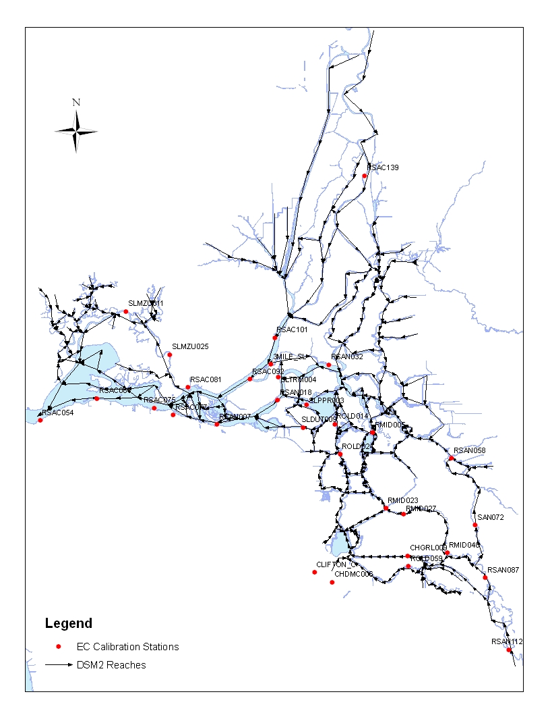

Figure EC Comparison Stations

The calibration started by scaling the 2009 BDCP calibration dispersion coefficients by 1200, i.e. *DC=DQQ x 1200*, where *DQQ* is the old dispersion coefficient, since previous experience showed this approach gave reasonable results. Then we calibrated the coefficients in groups from the West Delta to the South Delta in the trial runs. 11 adjustments and runs were taken to reach the satisfactory results, as described in the calibration notes.

30 stations with good data were selected and plotted. Mean Error, Percent Mean Error, RMSE and RSR are calculated and listed in Table 4 (the same metrics were calculated for 2009 calibration run and listed in Table 5 for comparison). Figure 12 through Figure 17 show the calibration metrics plots (including the 2009 calibration results for comparison) at key stations: Collinsville, Emmaton, Jersey Point, Old River at Bacon Island, Clifton Court Forebay, and Montezuma Slough at Beldons. Some outlier data points for monthly EC were taken out for regression analysis, including December 2000, 2002, 2003, 2004, 2005, and January 2001, when the model failed to predict the EC peaks, as seen in the daily plots of Figure 15 and Figure 16. The reasons for these missing peaks are not clear. By taking out these outliers, the statistical analyses are more meaningful and represent the model performance in other months better.

From Table 4, key stations including Collinsville, Emmaton, Antioch, Jersey Point, and Old River at Bacon Island have the smallest Percent Mean Errors(PME) within 5% and RSR values less than 0.5, which are better comparing to that of the 2009 calibration. The model consistently under-predicts San Joaquin River stations (RSAN072, RSAN058) and South Delta stations (ROLD059, CHGRL009, RMID027, CLIFTON COURT), where the PMEs are larger than -10%. The worst is Old River at Tracy Road (ROLD059) with percent mean error -22%. The RSR values of most of the stations are less or close to 0.5 except RMID027, ROLD059, RSAC101, and RSAN032, which may need to be further investigated. The predicted EC at Montezuma Slough stations (SLMZU011, SLMZU025) are much lower than observed, although the predicted EC matches the timing of salinity intrusion well. These biases are similar to the 2000, 2009 calibrations.

Figure 18 shows Martinez EC comparison was improved compared to the 2009 calibration as a result of correction of the Martinez boundary EC input data.

A lot of reasons might contribute to the errors in predicted EC, e.g. bathymetry, DICU, boundary flow and water quality measurement errors, over-simplification of the model formulation, etc. A 1D model such as DSM2 may be inadequate to accurately model areas that are highly two dimensional(e.g. shallow bays, such as Grizzly Bay, Suisun Bay, Franks Tract ) or three dimensional (e.g. stratification in West Delta). Further investigations are needed to improve the model calibration.

**Table 4 Summary of Error Estimates at Selected Stations**



**Table 5 Summary of Error Estimates Calculated for 2009 Calibration**





**Figure 12** Sacramento River at Collinsville (RSAC081)



Figure Sacramento River at Emmaton (RSAC092)



Figure San Joaquin River at Jersey Point (RSAN018)



Figure Old River at Bacon Island (ROLD024)

Figure Clifton Court Forebay



Figure Montezuma Sl at Beldons (SLMZU011)



Figure Martinez Boundary

**Summary**

DSM2 Version 8.1 incorporates latest improvements to DSM2 code and a new calibration with NAVD88 datum. The modifications of channel geometry interpolation and dispersion formulation in Version 8.1 improved the model reliability and convergence. Mass conservation was checked for both Hydro and Qual. Sensitivity and convergence tests were done to determine appropriate time steps to use. The conversion to NAVD88 stage datum improved the comparison of predicted and observed stages in the Delta. Errors in Clifton Court Gate operation data, Martinez stage data, and Martinez EC data were corrected.

The model predicted EC at key stations in Central Delta fairly well (Collinsville, Emmaton, Antioch, Jersey Point). The new calibrated model results are generally very close to the 2009 BDCP calibration results, although there are significant changes of Manning’s n values and dispersion coefficients. Improvements were seen in a few places in Hydro and Qual, but not as big as we hoped. Flow around Franks Tract area and EC at the South Delta are the most desirable to be improved.

This calibration was done mainly by adjusting Manning’s coefficient and dispersion coefficient values. Further improvements would involve bigger changes, e.g. improve the channel schematic, regenerate cross sections based on better bathymetry data, improve flow around Franks Track area, improved estimates of diversions, return flows, and return flow water quality, Clifton Court gate modeling improvement, etc.

## Acknowledgement

We would like to acknowledge Ralph Finch (DWR) for providing quality controlled data for the calibration, Lan Liang (DWR) for updating the historical run to 2012 and corrections made to Martinez stage and Clifton Court Gate operation data, Qiang Shu for help with vtools and some of the scripts used in the data analysis, and Parviz Nader-Tehrani for valuable suggestions.

## Reference

CH2M Hill. (2009 Oct). *DSM2 Recalibration.* Sacramento, CA: Prepared for the California Department of Water

Resources.

Liu, L., Ateljevich, E. (2011). Improvements to DSM2-Qual: Part 1 (Chapter 1). In *Methodology for Flow and Salinity Estimates in the Sacramento-San Joaquin Delta and Suisun Marsh: 32nd Annual Progress Report.*Sacramento: California Department of Water Resources, Bay-Delta Office, Delta Modeling Section.

Liu, L., & Sandhu, P. (2011). Improvements to DSM2-Qual: Part 2 (Chapter 2). In *Methodology for Flow and Salinity Estimates in the Sacramento-San Joaquin Delta and Suisun Marsh: 32nd Annual Progress Report.*Sacramento: California Department of Water Resources, Bay-Delta Office, Delta Modeling Section.

Liu, L., & Sandhu, N. (2011 Aug). Dispersion Recalibration with DSM2 Version 8.1.1. *DSM2 Users Group Newsletter*. Sacramento: California Department of Water Resources, Delta Modeling Section.

Liu, L., Ateljevich, E., & Sandhu, P. (2012). Improved Geometry Interpolation in DSM2-Hydro (Chapter 2). In

*Methodology for Flow and Salinity Estimates in the Sacramento-San Joaquin Delta and Suisun Marsh: 33rd Annual Progress Report.* Sacramento: California Department of Water Resources, Bay-Delta Office, Delta Modeling Section.

Liu, L., & Sandhu, P. (2012). DSM2 Version 8.1 Recalibration (Chapter 3). In *Methodology for Flow and Salinity Estimates in the Sacramento-San Joaquin Delta and Suisun Marsh: 33rd Annual Progress Report.* Sacramento: California Department of Water Resources, Bay-Delta Office, Delta Modeling Section.

Moriasi, D.N., J.G. Arnold, M.W. Van Liew, R.L. Bingner, R.D. Harmel, T.L. Veith. (2007). Model Evaluation Guidelines for Systematic Quantification of Accuracy in Watershed Simulations. Transactions of the ASABE. Vol.50(3):885-900.

Resource Management Associates (RMA 2005). Flooded Islands Pre-Feasibility Study: RMA Delta Model Calibration Report, prepared for CA Department of Water Resources for submittal to California Bay-Delta Authority, June 30.